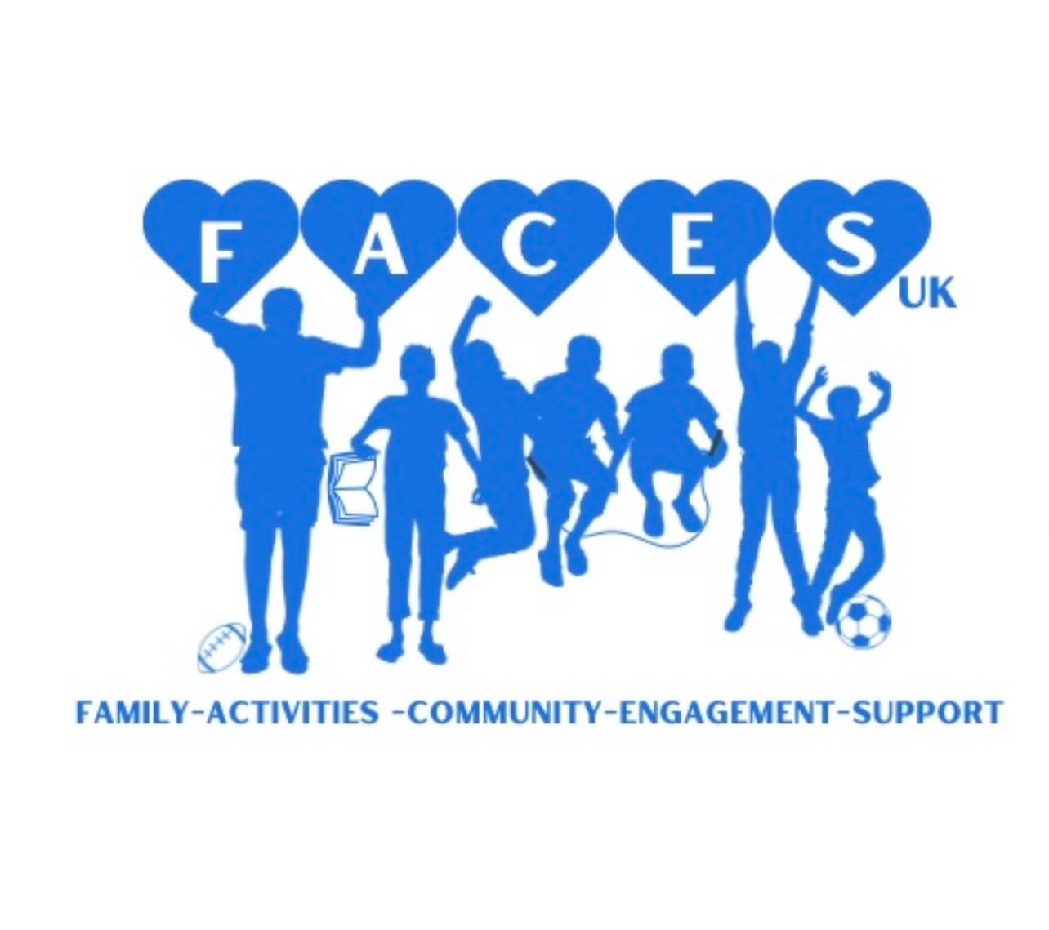
FACESuk CIC
Safeguarding and Child Protection Policy
Reviewed on: 18/09/2025
Next Review Date: 18/03/2026

1. Introduction
FACESuk CIC is committed to safeguarding and promoting the welfare of children, young people, and vulnerable adults. We expect all colleagues, staff, and volunteers to share this commitment.
We acknowledge both our legal and moral responsibility to protect children and adults at risk from harm and to provide a safe environment where they feel supported and respected.
Our safeguarding policy is built upon the following principles:
- The welfare of the child or vulnerable adult is paramount.
- All participants, regardless of age, gender, ability, disability, race, faith, culture, size, language, or sexual identity, have the right to protection from harm.
- We have a zero-tolerance approach to abuse, neglect, bullying, or discrimination of any kind.
- All concerns, suspicions, or allegations of abuse will be taken seriously and acted upon quickly, fairly, and appropriately.
- We will work in partnership with Essex statutory agencies, parents/carers, and other organisations to safeguard children and young people.
- Everyone has the right to expect safeguarding delivered by appropriately recruited, trained, and supported staff.

2. Designated Safeguarding Lead (DSL)
FACESuk CIC Safeguarding Lead:
- Bridie Stanford
- Tel: 07403 316735
- Email: support@facesukcic.com
Deputy Safeguarding Leads: Ellesha Lines 07947 873085 elleshalines@icloud.com, Paige French 07469 738327 frenchpaige13@gmail.com

3. Safer Recruitment and Training
- All staff and volunteers must hold a valid DBS check before starting work.
- Safeguarding training is mandatory at induction and refreshed regularly.
- Ongoing supervision and performance monitoring are in place to maintain safe standards of practice.

4. Recognising Abuse
All forms of abuse can occur in any family or community setting. Staff and volunteers must be alert to the four main categories of abuse:

Physical Abuse
- Hitting, shaking, burning, poisoning, use of implements.
- Signs: unexplained injuries, fear of going home, aggression, frequent absences.

Neglect
- Persistent failure to meet basic needs.
- Signs: constant hunger, poor hygiene, inappropriate clothing, untreated medical issues.

Emotional Abuse
- Persistent emotional ill-treatment undermining self-worth.
- Signs: low self-esteem, withdrawal, excessive clinginess, inappropriate responses to stress.

Sexual Abuse & Exploitation (CSE, FGM, Forced Marriage)
- Sexual exploitation of any kind, including online abuse.
- Signs: sexualised behaviour inappropriate to age, secrecy, unexplained gifts, depression.
- FGM and forced marriage are illegal and must be reported immediately to the police.

Peer-on-Peer Abuse
- Includes bullying, sexual harassment, exploitation, initiation rituals, and online abuse.
- Such incidents are treated with the same seriousness as adult-perpetrated abuse.

5. Responding to Concerns and Disclosures
If a child or vulnerable adult discloses abuse:
1. Listen and stay calm — do not judge, criticise, or promise confidentiality.
2. Reassure them — tell them they are brave and it is not their fault.
3. Ground them — return them to a calmer state through normal conversation.
4. Record carefully — use their exact words, distinguishing fact from opinion.
5. Report immediately — to the DSL (or deputy if DSL unavailable).
6. If urgent or life-threatening, call 999 immediately.

6. Reporting Procedures
- Concerns must be reported to the DSL as soon as possible.
- The DSL will assess whether to:
- Speak with parents/carers (if safe to do so), or
- Refer directly to Essex Social Care.
- All allegations against staff are reported to the Local Authority Designated Officer (LADO).
Emergency contacts:
- Essex Social Care (Children): 0345 603 7627 (Priority Line), Out of Hours: 0345 606 1212
- Essex Social Care (Adults): 0345 603 7630
- NSPCC Helpline: 0808 800 5000
- Childline: 0800 1111
- Essex Police: 999 (emergency) / 101 (non-emergency)
- COMPASS Domestic Abuse Helpline (Essex): 0330 333 7444
- Crimestoppers: 0800 555 111

7. Allegations Against Staff or Volunteers
If there is a serious allegation against a FACESuk CIC colleague:
- The individual will be suspended during the investigation (to protect all parties).
- They must cooperate fully, avoid contact with the child, and will receive support from management.
- FACESuk CIC has a legal duty to inform the Disclosure and Barring Service (DBS), even if the individual resigns before an investigation is completed.

8. Whistleblowing
FACESuk CIC encourages staff, volunteers, and service users to raise concerns if they feel safeguarding issues are not being properly addressed.
- Concerns can be raised directly with the DSL, a Director, or Essex Social Care.
- Whistleblowers will be protected from harassment or victimisation.

9. Staff and Volunteer Conduct
To protect both participants and themselves, colleagues must:
- Avoid being alone with a child (unless risk assessed).
- Keep accurate attendance registers for all sessions.
- Ensure doors remain open when working in enclosed spaces.
- Never engage in play-fighting, lap-sitting, or humiliating behaviour.
- Use professional language at all times.
- Maintain professional boundaries online — no social media contact with children or their friends.
- Follow strict rules on photography: only permitted where parental consent is obtained, photos must be appropriate, and all images deleted from personal devices after use.

10. Anti-Bullying, Equality & Inclusion
FACESuk CIC has a zero-tolerance approach to bullying.
- Any bullying concerns will be reported to session leaders and escalated to the DSL.
- We actively promote inclusion, equality, and celebrate diversity in all our work.

11. Safe Activities and Environments
- All staff/volunteers must have valid DBS checks.
- Risk assessments are required for all activities and reviewed regularly.
- At least one trained first aider will be present at every activity.
- Health & Safety (including fire safety and equipment checks) is a standing agenda item in staff meetings.
- Insurance certificates are held and displayed as required.

12. Confidentiality & Data Protection
- All safeguarding records will be kept securely in line with the Data Protection Act 2018 (GDPR).
- Information will only be shared on a strict “need-to-know” basis with appropriate authorities.
- Staff and volunteers must handle all personal data lawfully, fairly, and transparently.

13. Support for Families and Children
- FACESuk CIC seeks to build trusting, supportive relationships with children, vulnerable adults, and families.
- We will respect parents/carers while always prioritising the child’s welfare.
- Where abuse is suspected, we will continue to provide support while investigations take place.
14. Good Practice Guidelines
All personnel should demonstrate exemplary behaviour to promote children’s welfare and reduce the likelihood of allegations:
- Always work in an open environment; avoid private/unobserved situations and encourage open communication.
- Treat all young people/disabled adults equally, with respect and dignity.
- Put the welfare of each child/adult first, before winning or achieving goals.
- Build balanced relationships based on mutual trust, empowering children to participate in decision-making.
- Make activities fun, enjoyable, and promote fair play.
- Be an excellent role model — no smoking or drinking alcohol in the company of young people.
- Give constructive, enthusiastic feedback rather than negative criticism.
- Recognise developmental needs; avoid excessive training or competition against their will.
- Keep written records of any injuries and treatments.

15. Practices Never to be Sanctioned
Personnel must never:
- Engage in rough, physical, or sexually provocative games, including horseplay.
- Allow or engage in inappropriate touching.
- Allow children to use inappropriate language unchallenged.
- Make sexually suggestive comments to a child, even in fun.
- Reduce a child to tears as a form of control.
- Fail to act upon or record allegations made by a child.
- Do personal tasks for children/adults that they can do themselves.
16. Prevent Duty
FACESuk CIC recognises its duty to prevent children and families being drawn into terrorist or extremist behaviour:
- Follows guidance in ‘Prevent duty guidance for England and Wales 2015’.
- Colleagues have access to Prevent training.
- We value all children and families equally.
- Promote positive attitudes and behaviours toward all people.
- Commit to challenging prejudice.
- Report concerns about children, colleagues, or families to the relevant authorities.

17. Policy Transparency
This safeguarding policy will be made available on request and displayed where appropriate so parents/carers, staff, and volunteers can access it.

18. Review
This policy will be reviewed annually or sooner if legislation or guidance changes.

